**REDMINE**

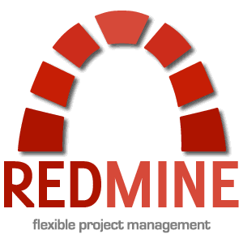

It is a tool for project management and issue tracking open source web based. It allows users to manage multiple projects and their subprojects. For each project it provides useful tools such as wikis and forums, time tracking and flexible access control based on roles.

Redmine also offers classic functionalities in project management activities as calendar or Gantt charts, which allows a comfortable visual monitoring of the lines of work.

**characteristics**

* Support for multiple projects (with their respective sub-projects).
* Flexible access control based on roles.
* Flexible issue tracking system.
* Gantt charts and calendar.
* Manager news, documents and files.
* Feeds and email notifications.
* Wiki for each project.
* Forum for each project.
* Monitoring timelines (work).
* Custom fields for issues, time entries, projects and users.
* Integration with control systems most used versions (Subversion, CVS, Git, Mercurial, Bazaar and Darcs).
* Creating incidents via email.
* Support for multiple LDAP authentication.
* Support for auto-registration of users.
* Support for 34 languages ​​(including Spanish course).
* Support for multiple systems databases (including MySQL, PostgreSQL and SQLite).
* Extension through plugins.

Redmine can help us greatly to swiftly manage the project of our company, associated documentation, we attach files and all controlling at all times the execution thereof. Despite all the functionality it is relatively easy to administer, to define workflows without having to be constantly answering questions that can be answered through a forum or already documented.